Chapter 9.5 Lab: Controlling Services and Daemons

Marko Shaffer

Information Technology, Franklin University

ITEC 200: Linux Fundamentals

Professor Kagan Ulucay

7/2/2023

**Red Hat System Administration I 8.2**

**Lab 07 – CH 9.5 Lab: Controlling Services and Daemons**

# ****Performance Checklist****

# ****In this lab, you will configure several services to be enabled or disabled, running or stopped, based on a specification that is provided to you.****

# ****Outcomes****

**You should be able to enable, disable, start, and stop services.**

# ****Log in to workstation as student using student as the password.****

|  |  |  |  |
| --- | --- | --- | --- |
|  | Franklin VM: | Standard User Account: | The Student's Root Account: |
| Username | kiosk | student | root |
| Password | redhat | student | redhat |

<https://franklin.instructure.com/courses/12488/modules/items/683350>

[kiosk@foundation0 ~]$ rht-vmctl start all

[kiosk@foundation0 ~]$ rht-vmview view workstation

# ****Start Lab****

From **workstation**, run the **lab services-review start** command. The command runs a start script that determines whether the host, **serverb**, is reachable on the network. The script also ensures that the **psacct** and **rsyslog** services are configured appropriately on **serverb**.

**[student@workstation ~]$ lab services-review start**

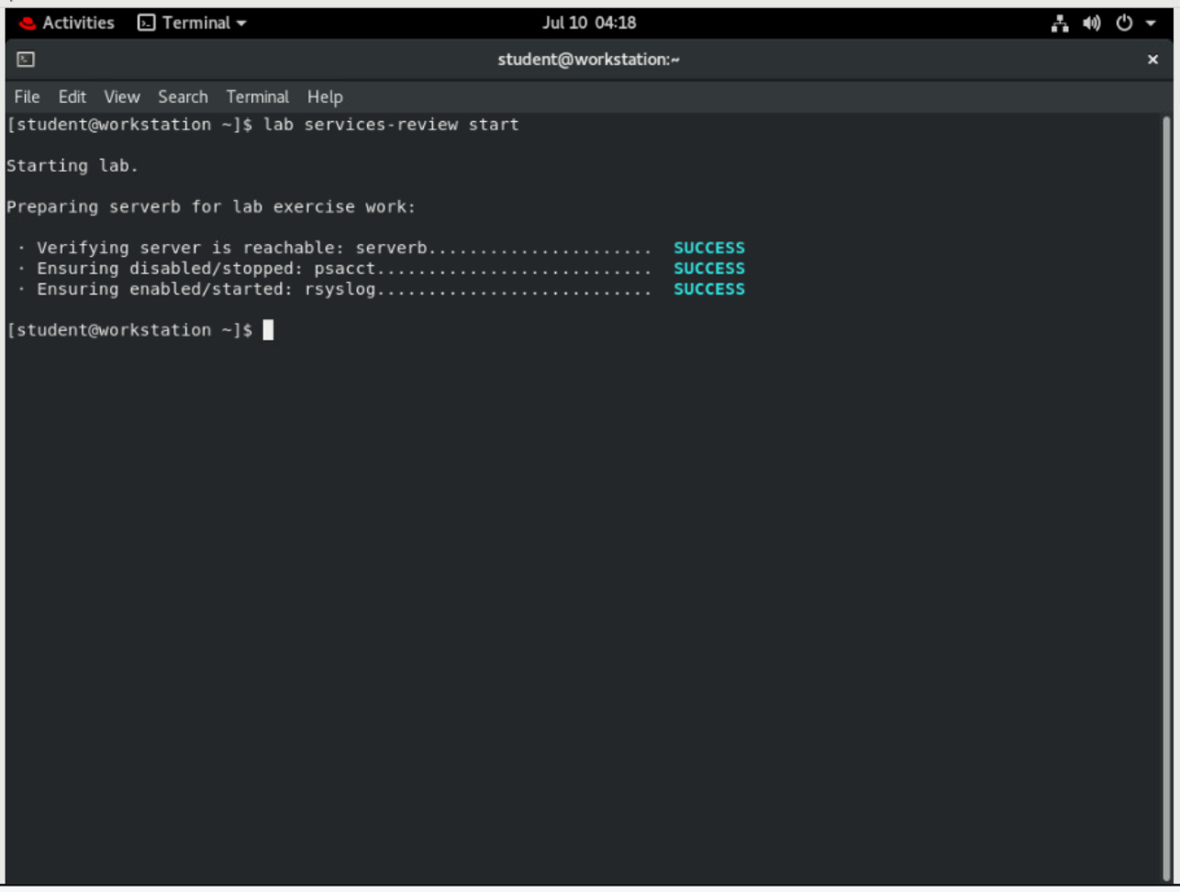

## On serverb, start the psacct service.

## Use the ssh command to log in to serverb as the student user.

**[student@workstation ~]$ ssh student@serverb**

*...output omitted...*

**[student@serverb ~]$**

## Use the systemctl command to verify the status of the psacct service. Notice that psacct is stopped and disabled to start at boot time.

**[student@serverb ~]$ systemctl status psacct**

● psacct.service - Kernel process accounting

Loaded: loaded (/usr/lib/systemd/system/psacct.service; **disabled**; vendor preset: disabled)

**Active**: **inactive** (dead)

## Start the psacct service.

**[student@serverb ~]$ sudo systemctl start psacct**

[sudo] password for student: **student**

**[student@serverb ~]$**

## Verify that the psacct service is running.

**[student@serverb ~]$ systemctl is-active psacct**

active

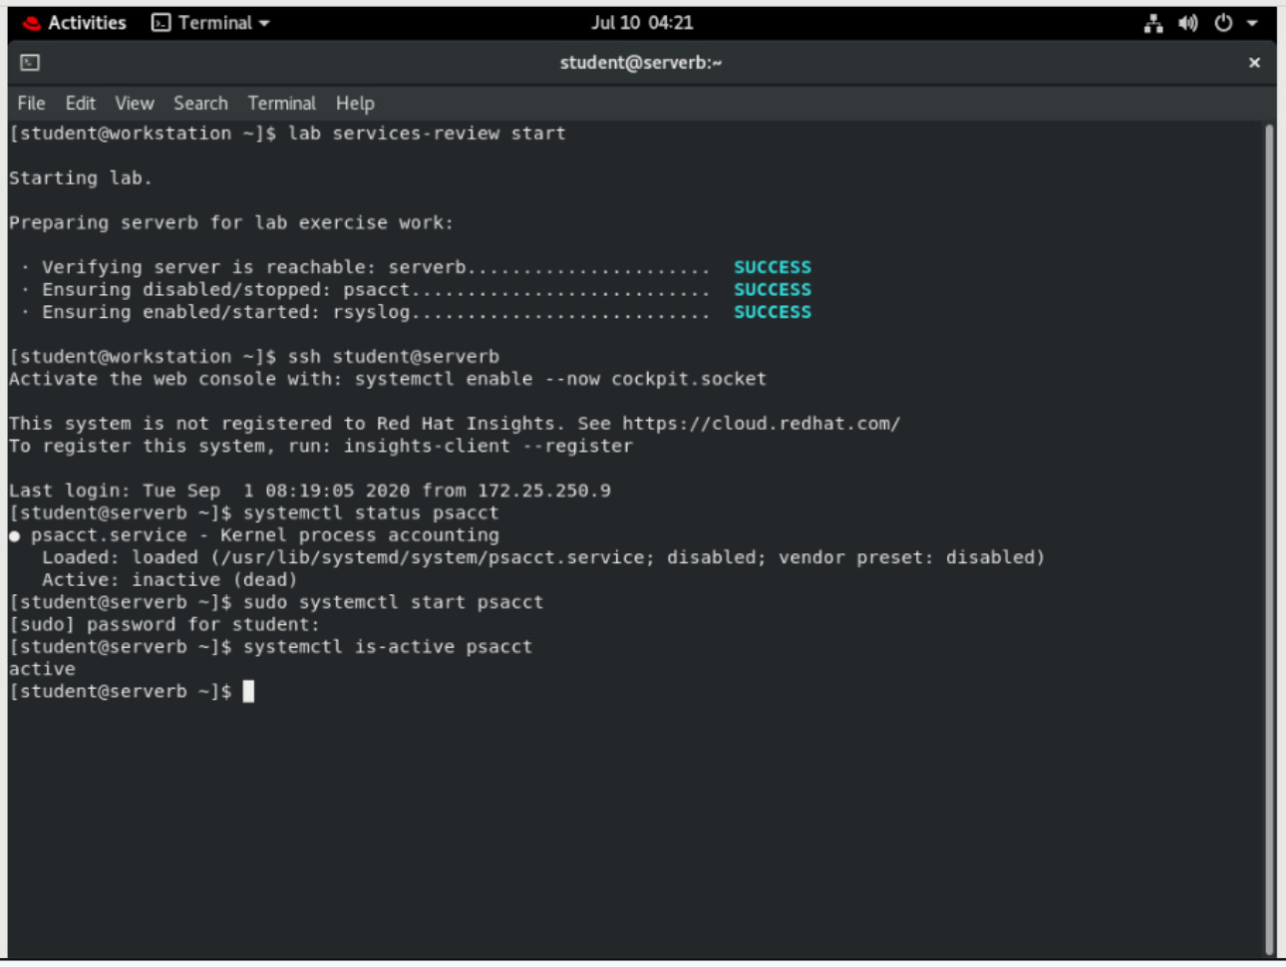

## In the right window, run the top utility.

## Enable the psacct service to start at system boot.

**[student@serverb ~]$ sudo systemctl enable psacct**

**Created symlink /etc/systemd/system/multi-user.target.wants/psacct.service → /usr/lib/systemd/system/psacct.service.**

## Verify that the psacct service is enabled to start at system boot.

**[student@serverb ~]$ systemctl is-enabled psacct**

**enabled**

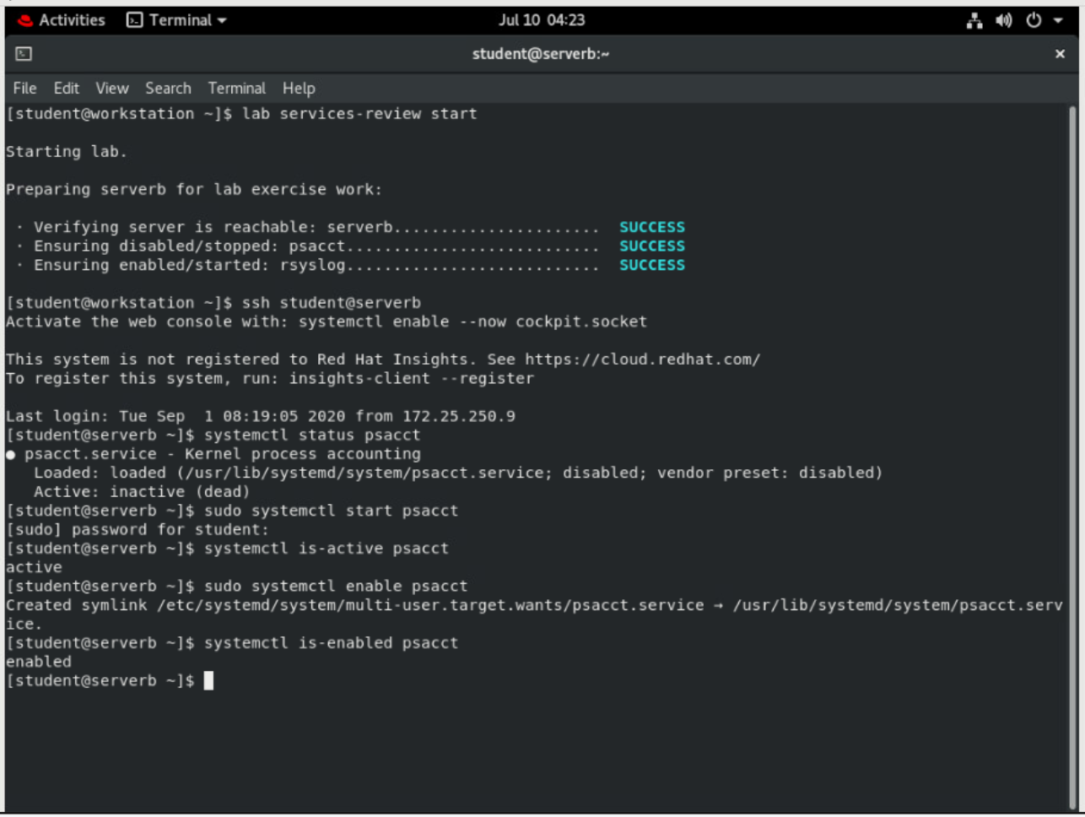

## Stop the rsyslog service.

## Use the systemctl command to verify the status of the rsyslog service. Notice that the rsyslog service is running and enabled to start at boot time.

**[student@serverb ~]$ systemctl status rsyslog**

● rsyslog.service - System Logging Service

Loaded: loaded (/usr/lib/systemd/system/rsyslog.service; **enabled**; vendor preset: enabled)

**Active**: **active** (**running**) since Fri 2019-02-08 10:16:00 IST; 2h 34min ago

*...output omitted...*

Press **q** to exit the command.

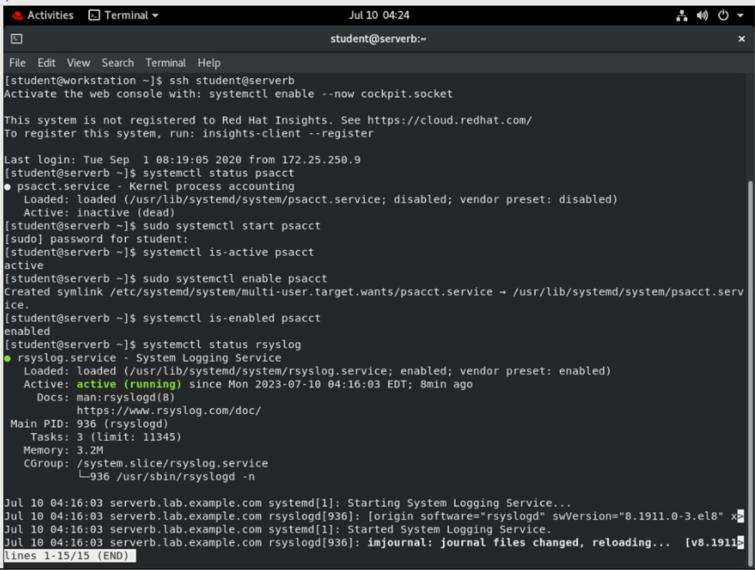

## Stop the rsyslog service.

**[student@serverb ~]$ sudo systemctl stop rsyslog**

[sudo] password for student: **student**

**[student@serverb ~]$**

## Verify that the rsyslog service is stopped.

**[student@serverb ~]$ systemctl is-active rsyslog**

inactive

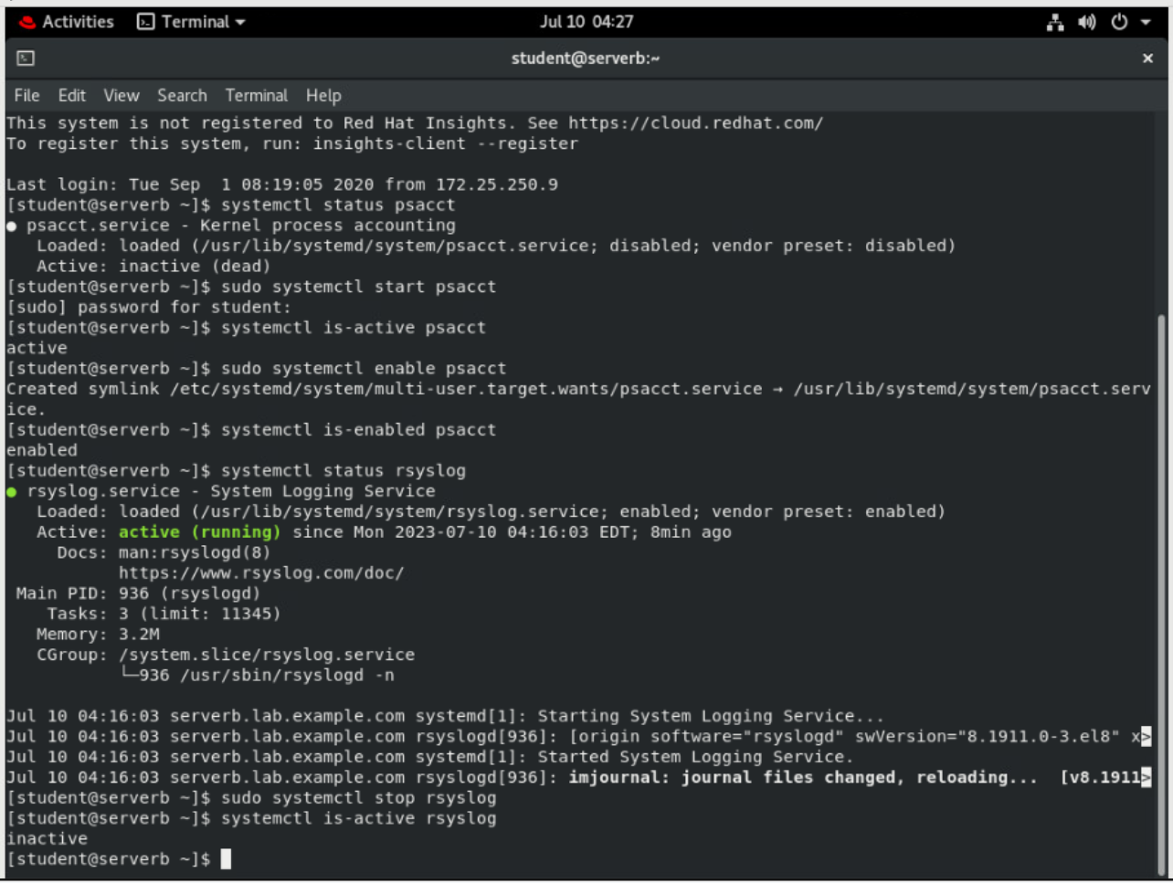

## Configure the rsyslog service so that it does not start at system boot.

## Disable the rsyslog service so that it does not start at system boot.

**[student@serverb ~]$ sudo systemctl disable rsyslog**

Removed /etc/systemd/system/syslog.service.

Removed /etc/systemd/system/multi-user.target.wants/rsyslog.service.

## Verify that the rsyslog is disabled to start at system boot.

**[student@serverb ~]$ systemctl is-enabled rsyslog**

disabled

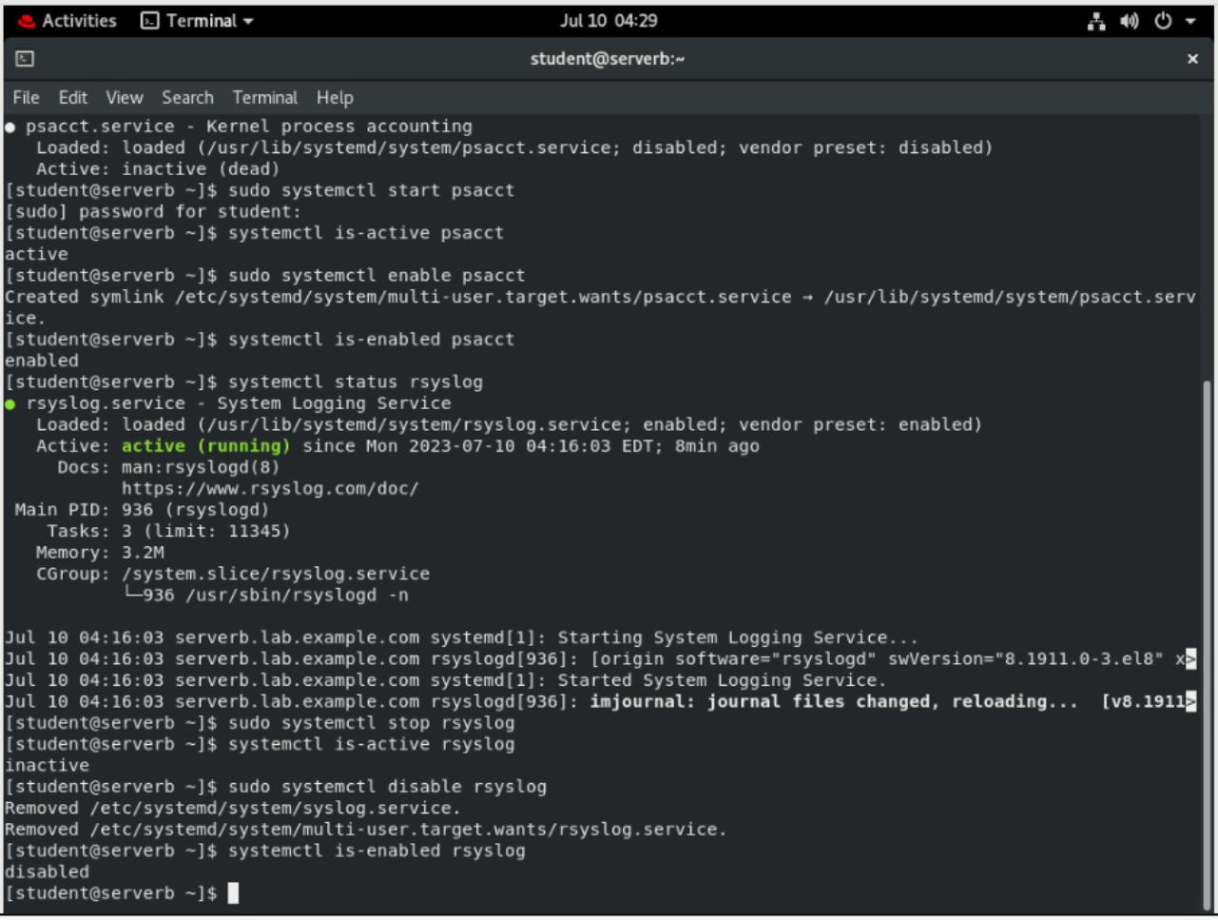

## Reboot serverb before evaluating the lab.

**[student@serverb ~]$ sudo systemctl reboot**

Connection to serverb closed by remote host.

Connection to serverb closed.

**[student@workstation ~]$**

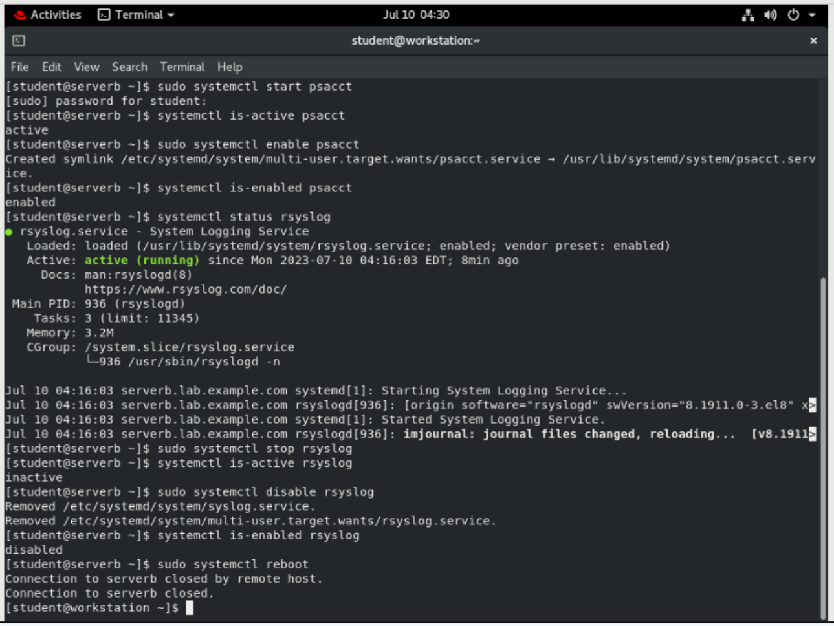

# Evaluation

On workstation, run the **lab services-review grade** script to confirm success on this lab.

**[student@workstation ~]$ lab services-review grade**

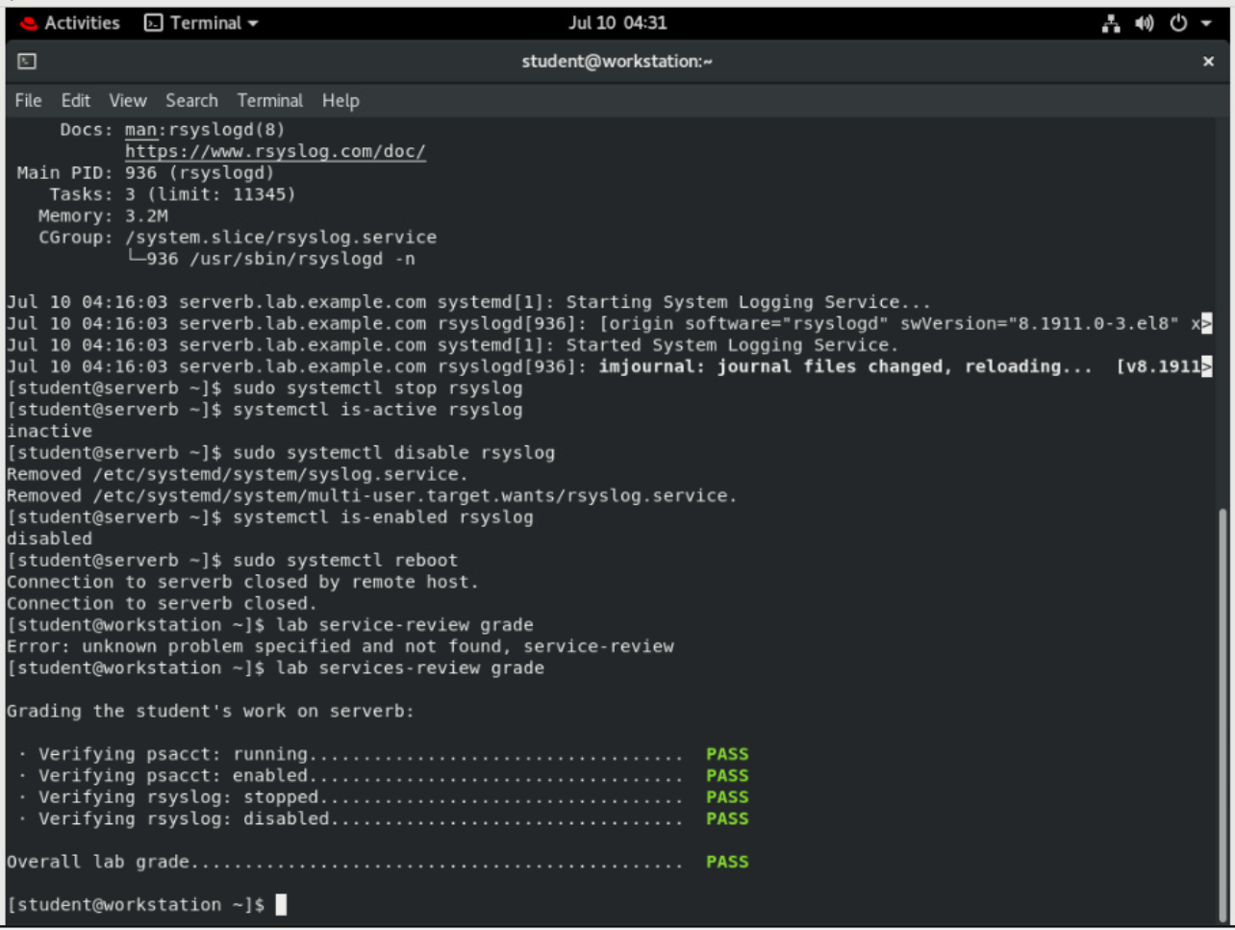

# Finish

On workstation, run the **lab services-review finish** script to complete this lab.

**[student@workstation ~]$ lab services-review finish**

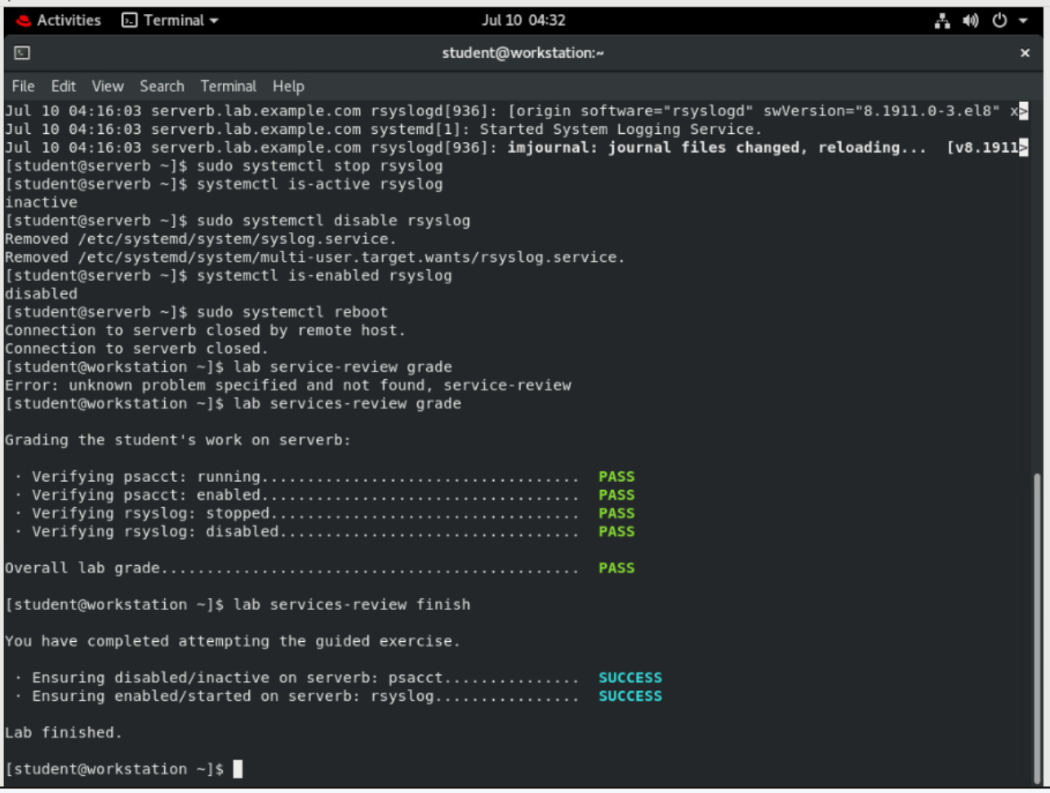

This concludes the lab.